PROJECT

How to use the accelerometer- gyroscope GY-521 with Arduino

The accelerometer measures the acceleration along one direction, while the gyroscope measures the angular acceleration on one axis.

Circuit and Working

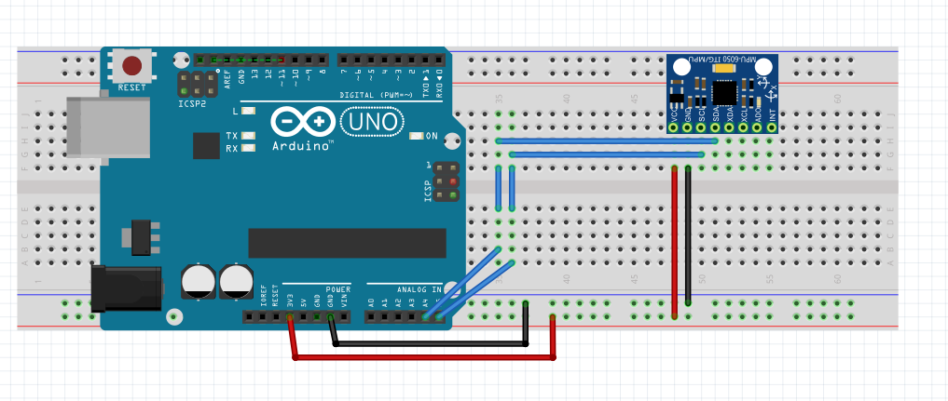

PIN CONNECTIONS

AND

WORKING

VCC -> 3.3 V / 5 V (better)

GND -> GND

SCL -> A5

SDA -> A4

XDA ->

XCL ->

ADO ->

INT ->

The analogic pins are not set on INPUT because it's their default setting. The values read by the analogic pins will be sent to the serial port.

Open the S*erial Monitor,* move the sensor and try to see how the values change.

Accelerometers can be used for fun projects, for example to realize a game controller.

CODE

#include<Wire.h>

const int MPU=0x68;

int16_t AcX,AcY,AcZ,Tmp,GyX,GyY,GyZ;

void setup(){

Wire.begin();

Wire.beginTransmission(MPU);

Wire.write(0x6B);

Wire.write(0);

Wire.endTransmission(true);

Serial.begin(9600);

}

void loop(){

Wire.beginTransmission(MPU);

Wire.write(0x3B);

Wire.endTransmission(false);

Wire.requestFrom(MPU,12,true);

AcX=Wire.read()<<8|Wire.read();

AcY=Wire.read()<<8|Wire.read();

AcZ=Wire.read()<<8|Wire.read();

GyX=Wire.read()<<8|Wire.read();

GyY=Wire.read()<<8|Wire.read();

GyZ=Wire.read()<<8|Wire.read();

Serial.print("Accelerometer: ");

Serial.print("X = "); Serial.print(AcX);

Serial.print(" | Y = "); Serial.print(AcY);

Serial.print(" | Z = "); Serial.println(AcZ);

Serial.print("Gyroscope: ");

Serial.print("X = "); Serial.print(GyX);

Serial.print(" | Y = "); Serial.print(GyY);

Serial.print(" | Z = "); Serial.println(GyZ);

Serial.println(" ");

delay(333);

}

